**GOVERNMENT OF TAMILNADU**

**Naan Mudhalvan – Project Based Experiential Learning**

Project Report on

**ESTIMATION OF BUSINESS EXPENSES**

**Submitted by**

**S. AYISHA (EF9248FCF2A65A690AC4A0FD739B2303)**

**M. GANGA (A581CA9A31D16FEA066443471356AB2D)**

**M. GAYATHRI (23DCCBFAE3184278E874151433F54BD2)**

**K. VANITHA (72A0B5448B132E483824B1322FE37826)**

**(TEAM ID : NM2023TMID07133)**

**Under the guidance of**

**Dr. M. GAYATHRI M.Sc., Ph.D**

**Guest Lecturer**

**Department of Mathematics**

GOVERNMENT ARTS COLLEGE FOR WOMEN,

(Affiliated to Mother Teresa Women’s University, Kodaikanal)

Reaccredited with “C” Grade by NAAC

NILAKOTTAI-624 208

**INTRODUCTION:**

   1.1.Overview

                         This report delves into the fascinating realm of business expenses and provides a visual exploration of the various expenditures incurred by different businesses. It showcases the distribution of expenses, identifies key cost drivers, and highlights areas of potential optimization or concern. The visual representations allow for intuitive analysis, facilitating a deeper understanding of expenditure patterns and their implications for business performance. Decision-makers, financial analysts, and stakeholders can gain valuable insights into the financial health of businesses, identify areas of inefficiency or opportunity, and make informed decisions to optimize resources and drive growth. To Extract the Insights from the data and put the data in the form of visualizations, Dashboards and Story we employed Tableau tool.

  1.2.Purpose

                  The primary business requirements for this report are to visualize and analyse business expenses, provide industry-specific insights, identify cost drivers, highlight outliers, and offer interactive functionality. Stakeholders need a visual representation of expenses to compare and analyse spending patterns across different businesses and industries .The report should facilitate the identification of key cost drivers, enabling stakeholders to understand the primary factors contributing to expenses. Additionally, it should flag any outliers or anomalies for further investigation. The analysis of business expenses and financial management has a significant social impact. It contributes to economic ability by optimizing costs and fostering long-term sustainability Effective expense management creates job opportunities and supports the workforce. It allows for better resource allocation, enabling businesses to invest in innovation and community engagement. Responsible expense management aligns with societal expectations and promotes social responsibility. Non-profit organizations benefit from expense analysis, enabling them to maximize their impact. Overall, analysing and managing expenses positively influences economic growth, employment, stakeholder well-being, and social responsibility. Business Impact: Analysing business expenses has a profound impact on various aspects of business operations. It helps optimize costs, improve profitability, and ensure financial stability. Expense analysis enables businesses to allocate resources effectively, make informed decisions and create realistic budgets and forecasts. It enhances competitiveness, attracts investors, and mitigates financial risks. By understanding and managing expenses, companies can drive growth, maintain a strong financial position, and make strategic business decisions with confidence.

**Problem Definition & Design Thinking**

        Analysing estimation of business expenses by creating visualizations, dashboards,

stories using tableau.

2.1Empathy map:

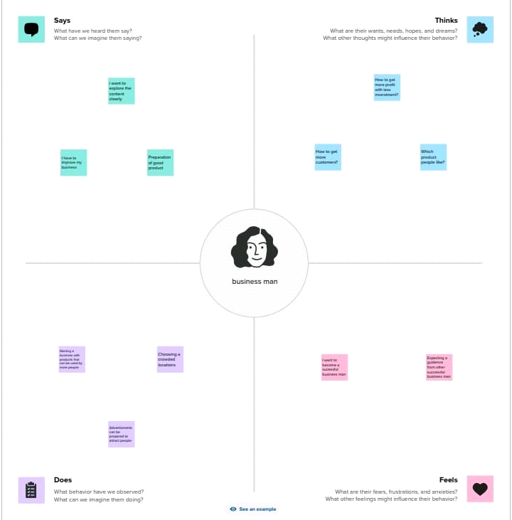

2.2. Ideation & Brainstorming map

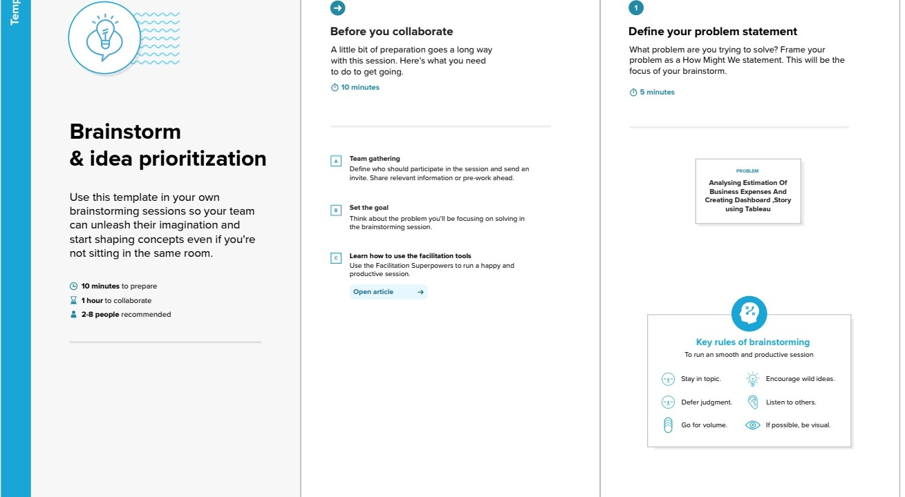

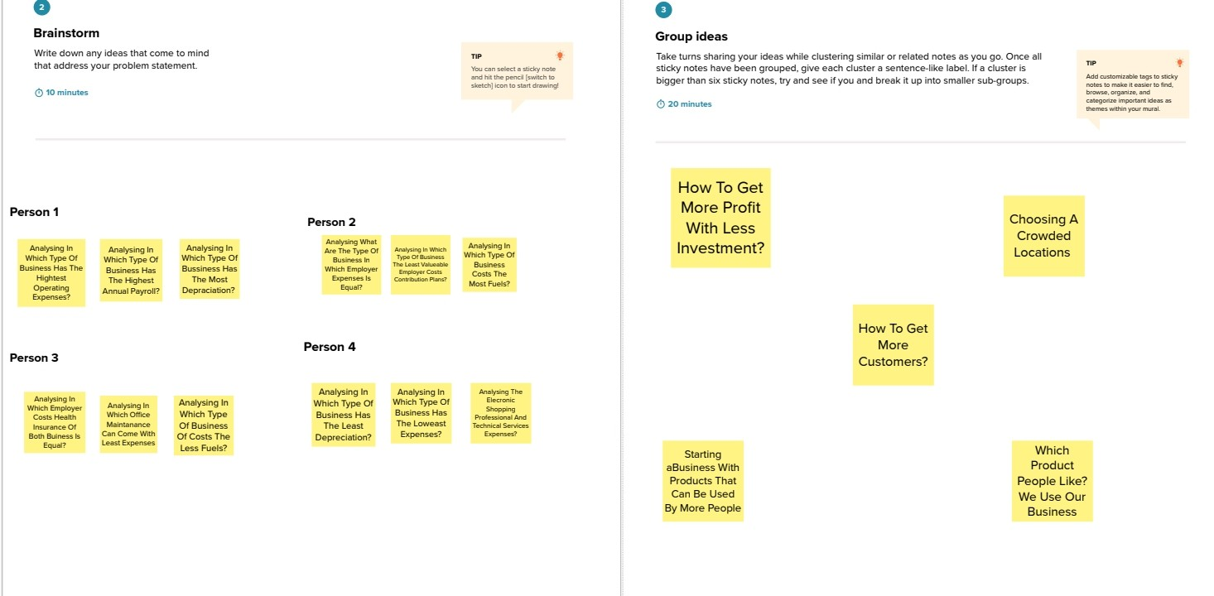

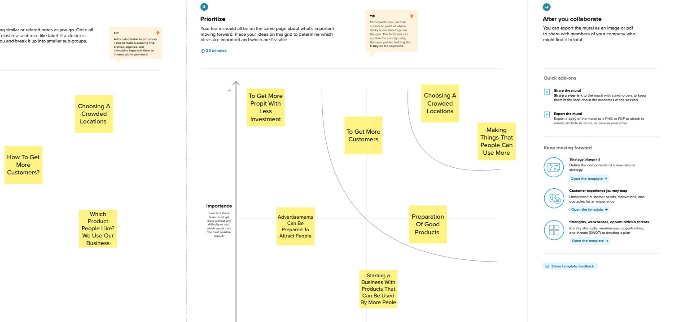

**RESULTS**

    Activity 1:

       Annual payroll

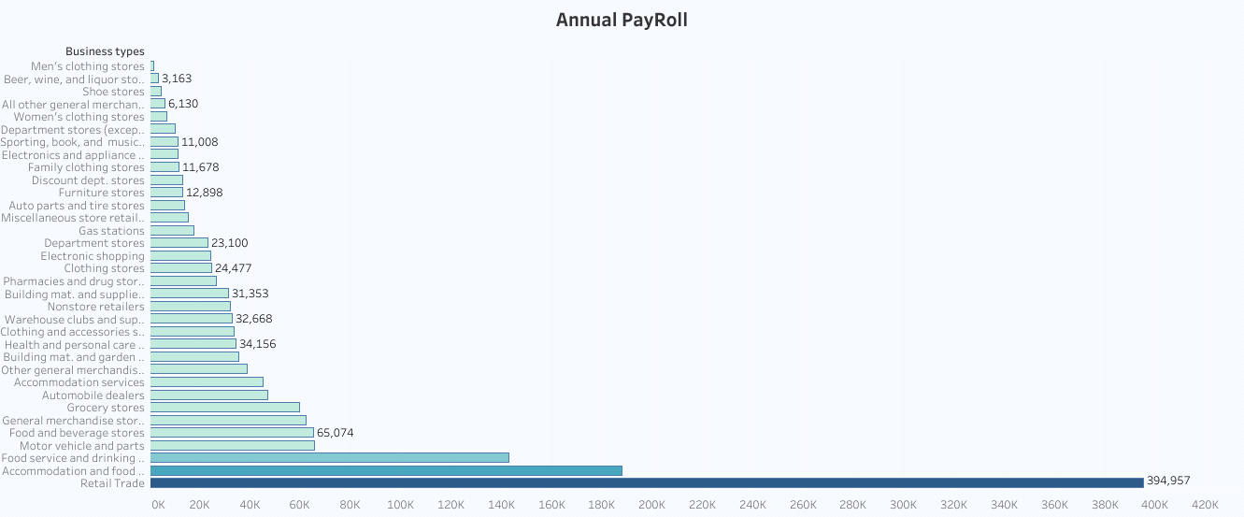

  Activity 2:

            Advertisement Cost

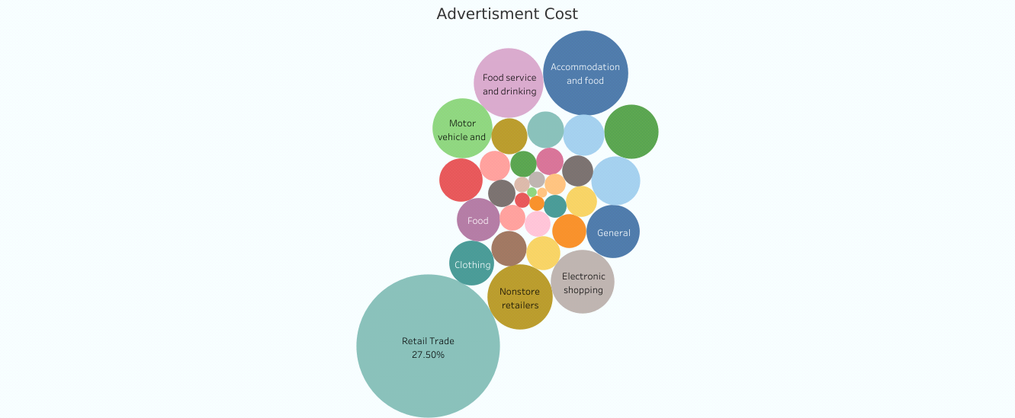

     Activity 3:

              Contact Labour vs Employee

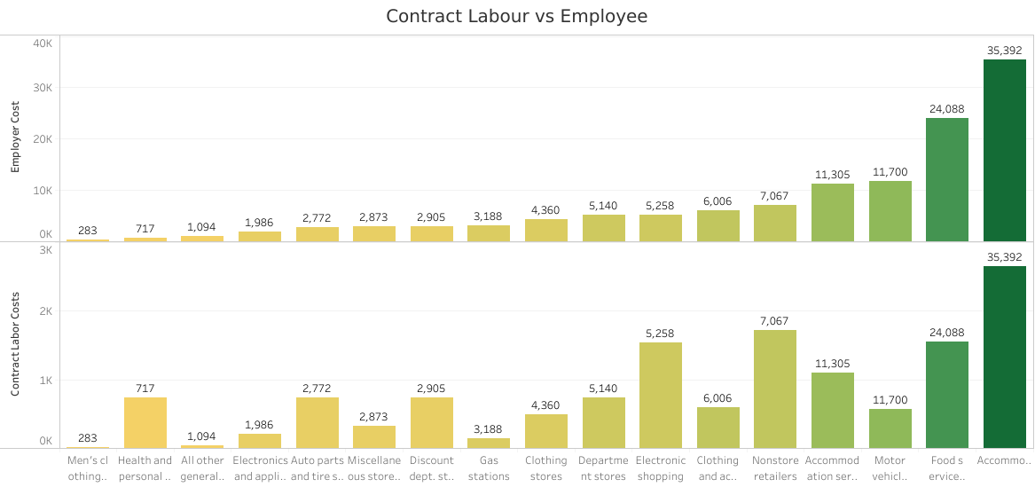

 Activity 4:

              Employee Cost (Insurance vs Pension)

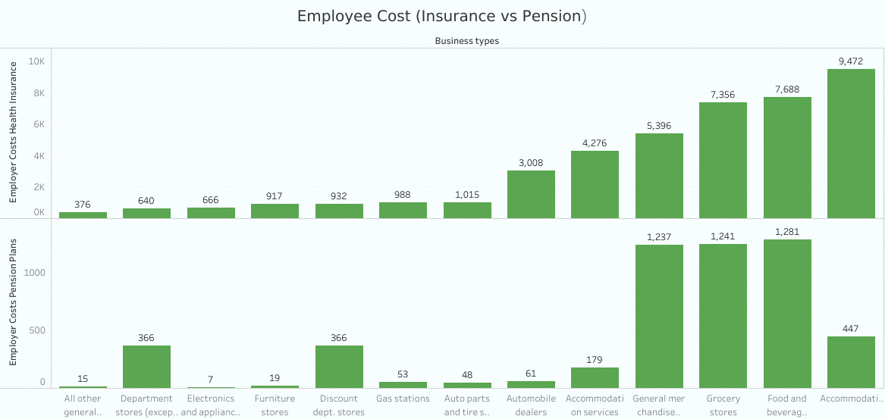

Activity 5:

         Equipment Costs

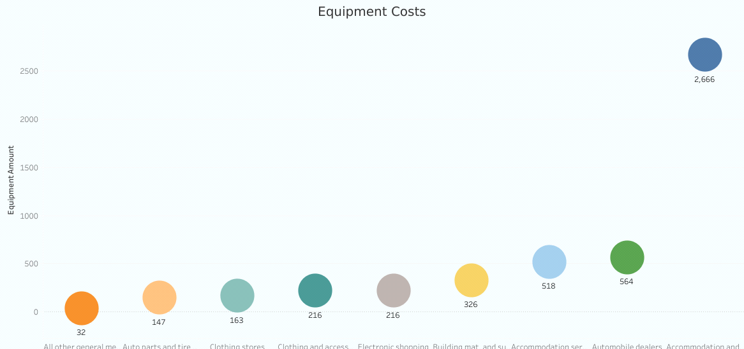

     Activity 6:

          Fuel

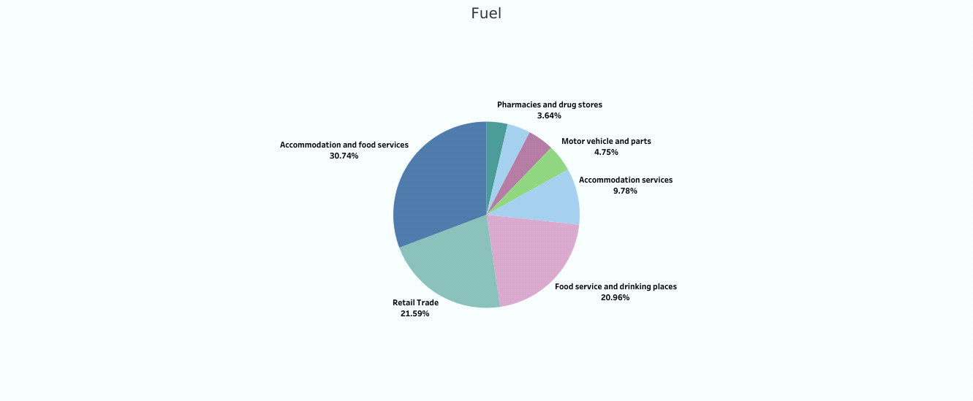

Activity 7:

        Maintenance Off Buildings

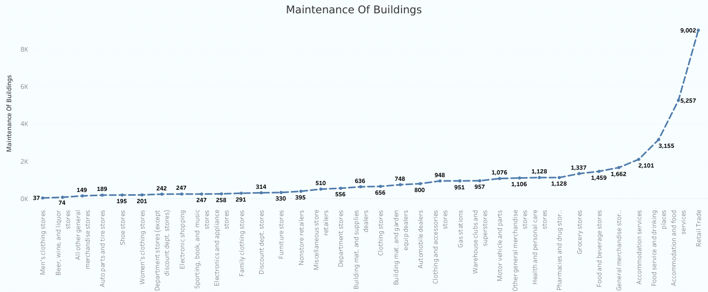

Activity 8:

        Power Expenditure

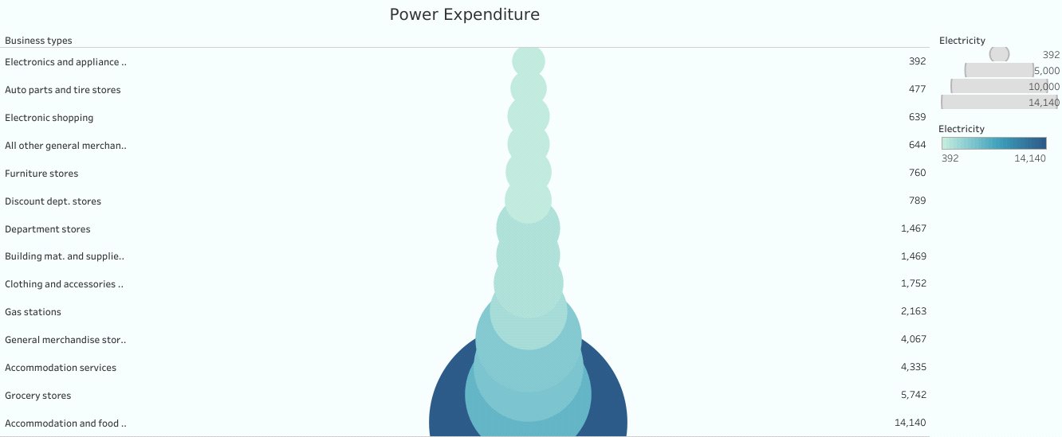

 Activity 9:

     Rental Payment For Machenery

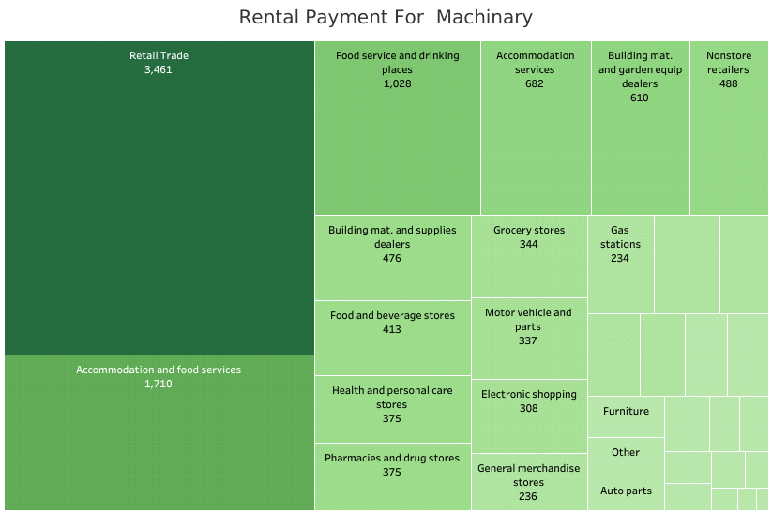

   Activity 10:

   Taxes & Licenses

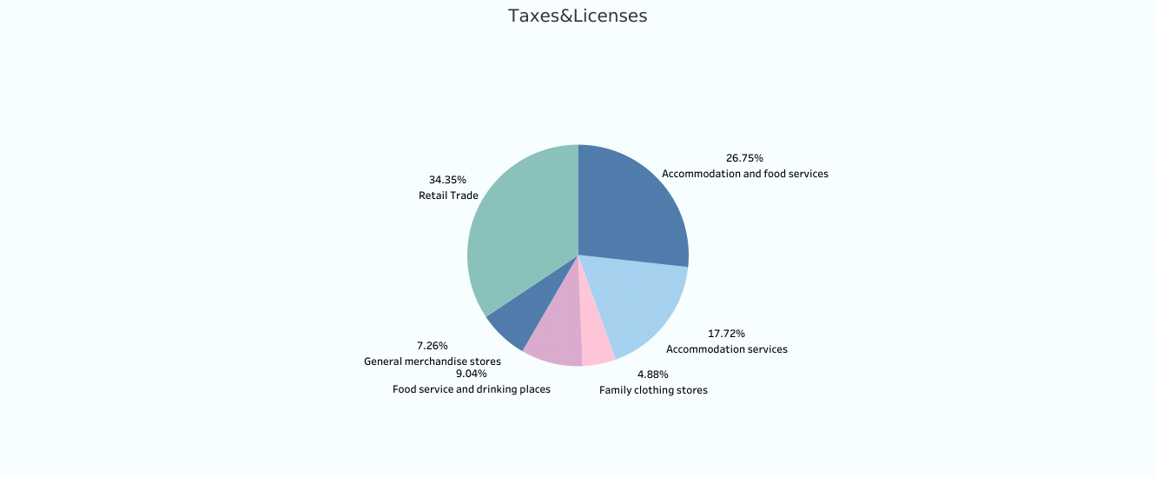

   Activity 11:

     Transportation and Warehousing

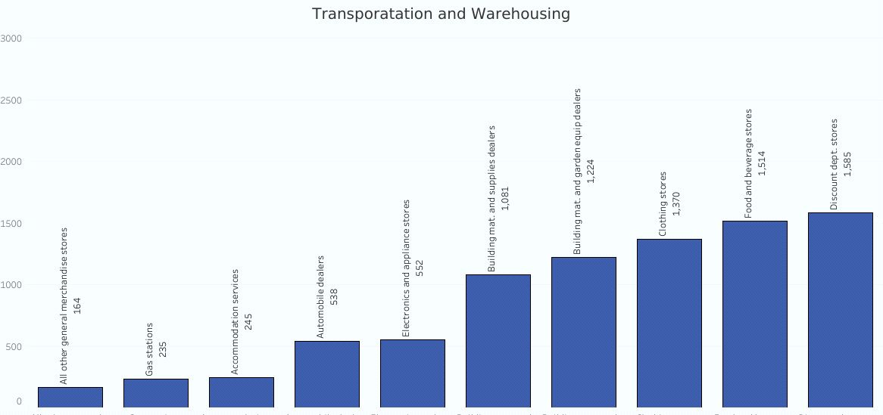

Dashboard 1: Bussiness Expenditure Overview

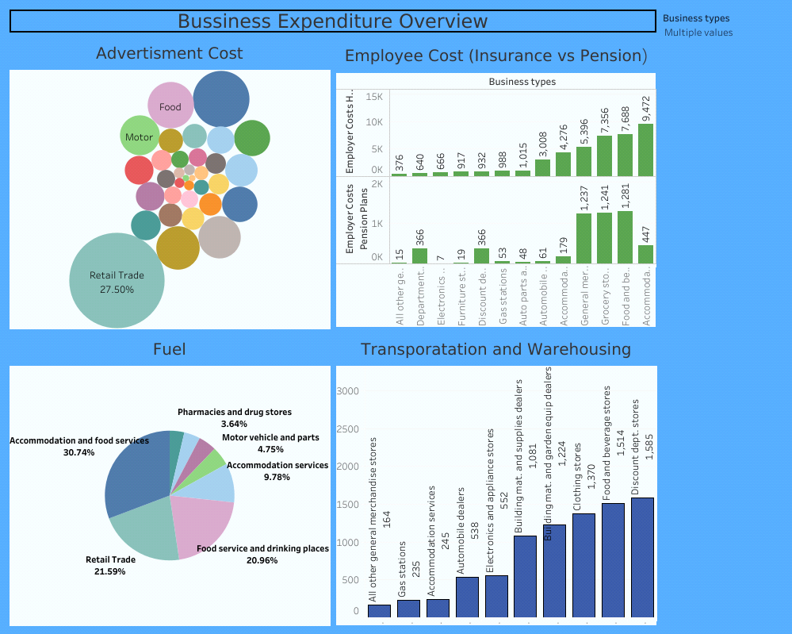

Dashboard 2: Expenses Insights

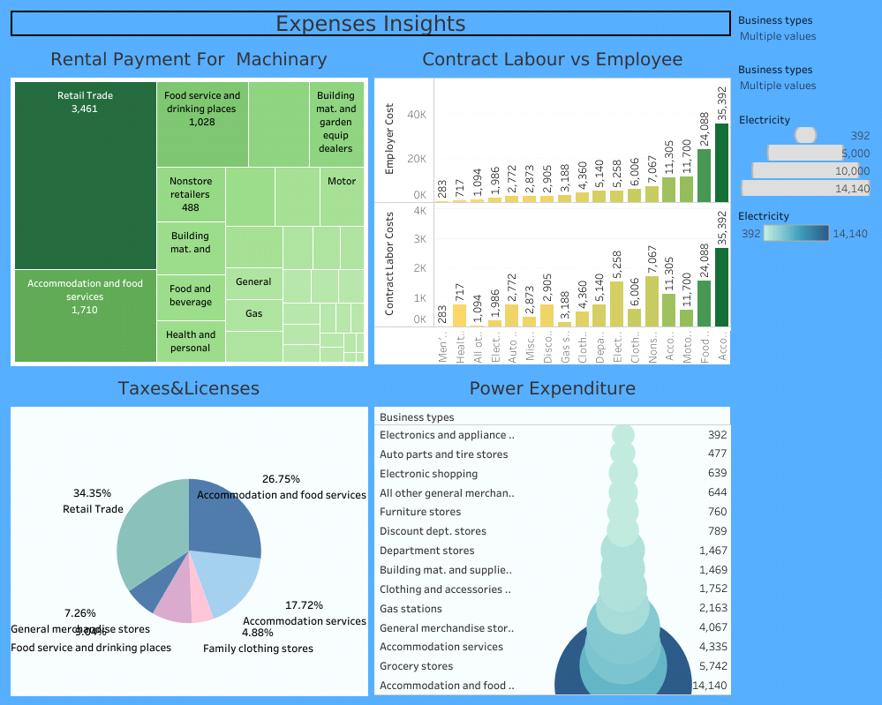

Dashboard 3:  Expenses Breakdown: Insights In to Business Costs

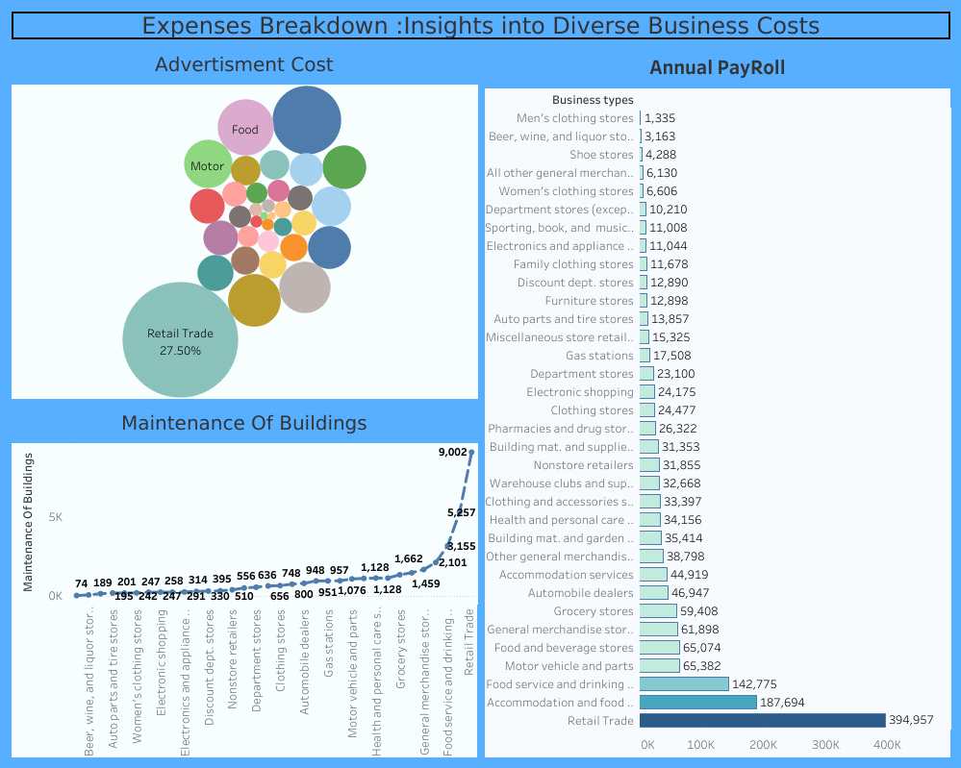

Story:

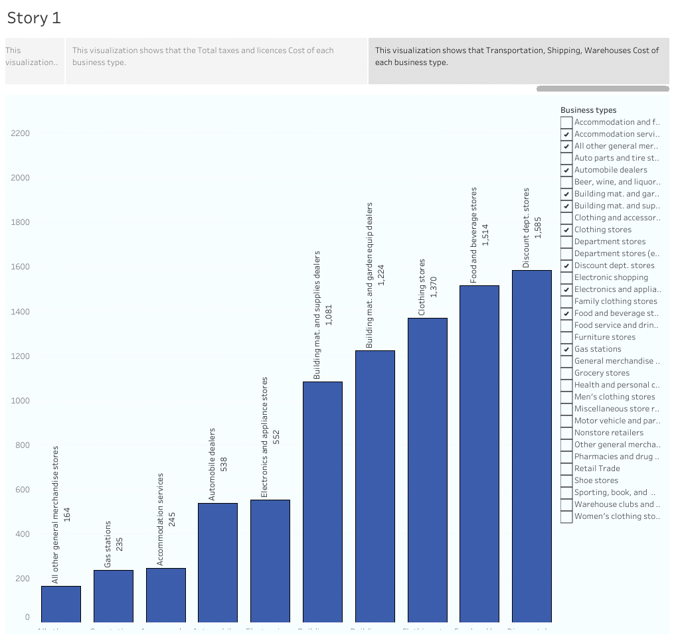

**Advanteges & Disadvantages**

         Social Impact: The analysis of business expenses and financial management has a significant social impact. It contributes to economic stability by optimizing costs and fostering long-term sustainability. Effective expense management creates job opportunities and supports, Work force. It allows for better resource allocation, enabling businesses to invest in innovation and community engagement. Responsible expense management aligns with societal expectations and promotes social responsibility. Non-profit organizations benefit from expense analysis, enabling them to maximize their impact. Overall, analysing and managing expenses positively influences economic growth, employment, stakeholder well-being, and social responsibility.

Business Impact: Analysing business expenses has a profound impact on various aspects of business operations. It helps optimize costs, improve profitability, and ensure financial stability. Expense analysis enables businesses to allocate resources effectively, make informed decisions, and create realistic budgets and forecasts. It enhances competitiveness, attracts investors, and mitigates financial risks. By understanding and managing expenses, companies can drive growth, maintain a strong financial position, and make strategic business decisions with confidence.

**5 APPLICATIONS**

By analyzing the various expenses of various business, a business man can aware about his expenses and he can take steps to reduce his overall expenses.

**6 CONCLUSION**

In this project, we have analyzed annual payrole, advertisement cost, contract labour and employee expenses, Employees insurance cost, equipment cost, fuel cost, maintenance of building cost, power expenditure, rental payment for machinery, taxes and licenses cost, transportation and warehouse costs of each business type bu using tableau.

**7 FUTURE SCOPE**

In future, we can extend our analysis by considering other expenses and profits of each business type.